Midterm Review

- Data Structures
  - Abstract Data Types (ADT)
    - ADT: set of objects related to each other when set of operations:
      - compose the data type
      - relationship between individual objects
      - operations need to be performed
    - It is a mathematical abstraction
  - ADT vs Implementation
    - ADT is lasnguage independent
    - Implementations are language dependent
    - Each ADT functions is independent of implementation rather it’s the other way around
- Problem Solving
  - Terminology
    - Problem: defined by input and output
      - Format
The <name> problem is:
input: <definition of inputs>
output: <definition of outputs>
      - Example
The minimum problem is:
input: a list L of n > 0 comparable objects
output: the least element in L
    - Problem isntance: specific input to a problem
    - Process: series of actions directed to some end
    - Algorithm: ordered squence of number of steps
  - Pseudocode
    - Pseudocode: human-readable format for communicating algorithms using code-like syntax
    - Ex. pseudocode for minimum problem
Let min = first elmenet of L (therei sonce since n > 0)
For each element in L do
if (min > element) then let min = element
Return min
  - Implementation is the executable code
    - Ex. minimum problem in C++
float min;
int I;
min = L[0];
for (i=1;i<n;i++) do
if (min > L[i])
min = L[i];
return min;
- Quality of Algorithm
  - Time complexity: shorter execution time
  - Space complexity: smaller amount of memory
  - RAM: model of compuation and implementation
    - one memory (infinite)
    - One processor
    - Instructions executed sequentially
- Step count: running time/number of steps
  - in an algoirthm: it’s the sum of steps for each statement executed
  - It takes 1 unit to do anything simple
    - PEMDAS, assignment, comparison, read/write value
    - Consecutive statements add up
      - Ex. if/else
if (condition) = 1
S1 = 1
Else =1
S2 = 1
Total: 4 steps
    - The step count is <= number of steps to evalunate the condition plus larger of step count of S1 and S2
    - For loops: SC for for-loop is at most the SC of statements inside the for-loop x number of interations
    - Nested loops are analyzed inside out
    - Ex.
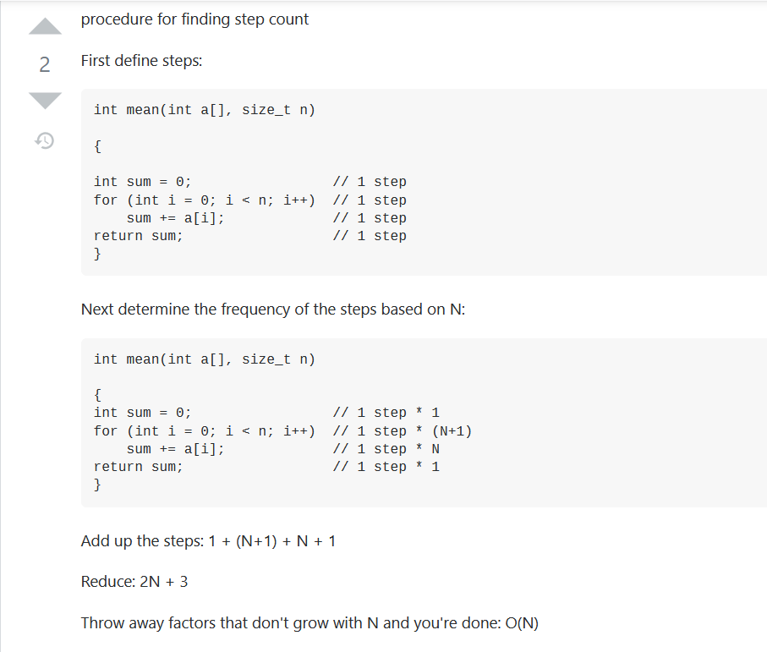
- Best-case vs Worst-case scenarios
  - Best case running time: minimum number of steps
  - Worst case: maximum number of steps
    - the upper bound
  - Average case: input chosen at random, average number of steps
    - usually as bad as worst-case
- Order of Growth or Rate of Growth (Big-O)
  - time complexity measured in growth rate
  - Execution time is proportional to n, size of input
  - Assumptions:
    - Constants are ignored
    - Only leading term is considered
- Analyzing Algorithms

